Conditions / Ifelse statements
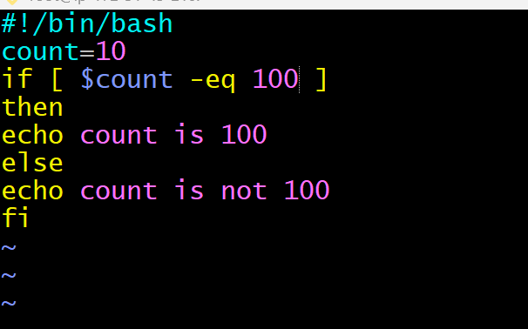
using if else statements
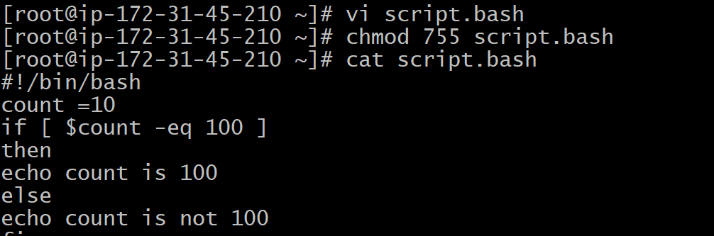
Created “File exist”
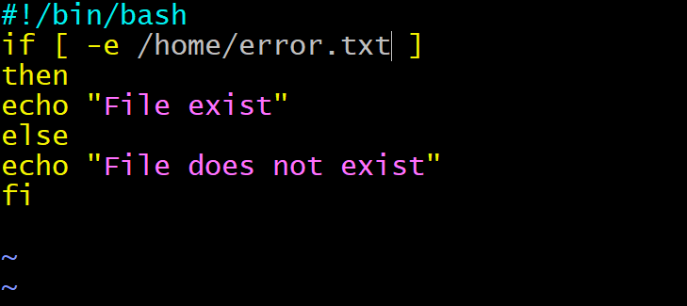

After creating file exist the expected output is
Output :
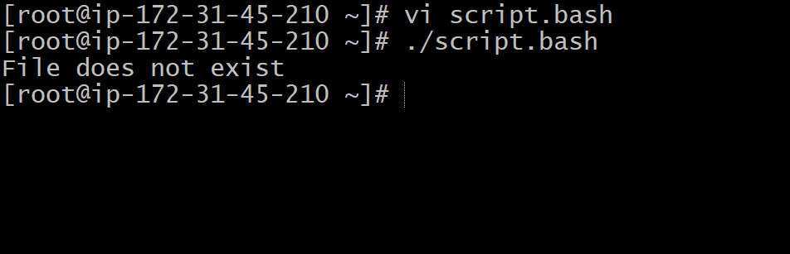
“Field does not exist” as I mentioned
Case statements scripts
* created a case statement script and executed the script.
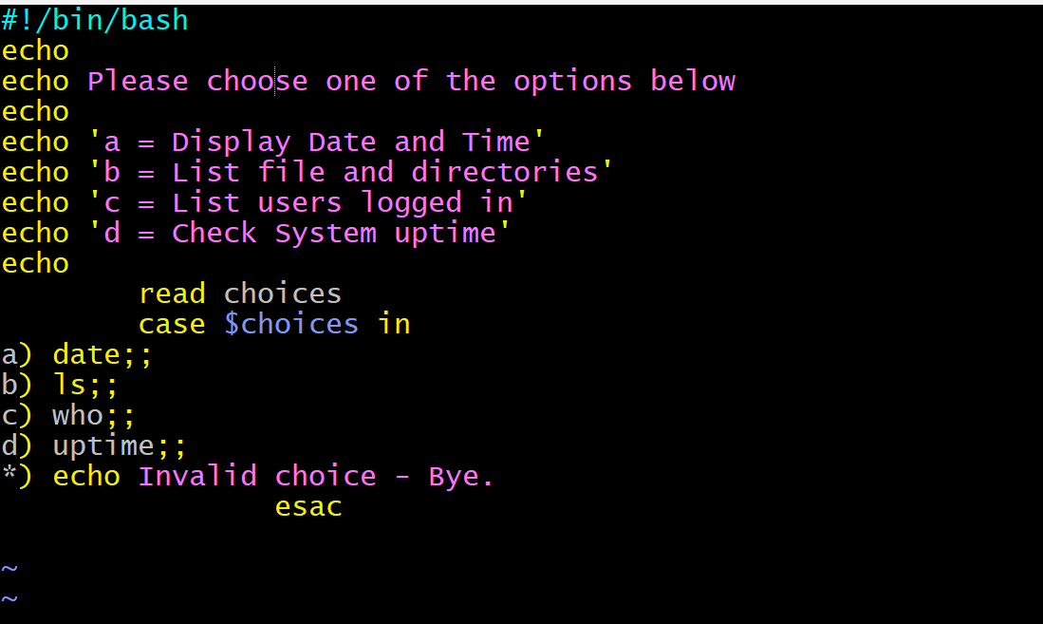

Output : For case statement scripts
* Given permission using chmod 755
* Created new case.bash
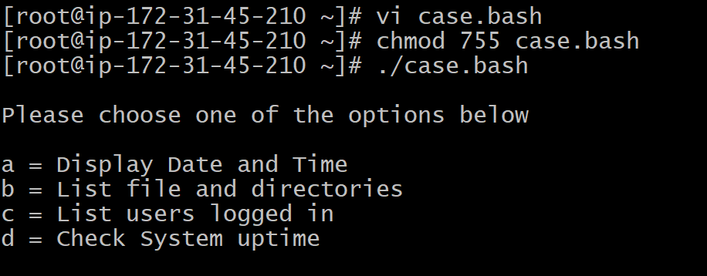
For Loop scripts

Output:
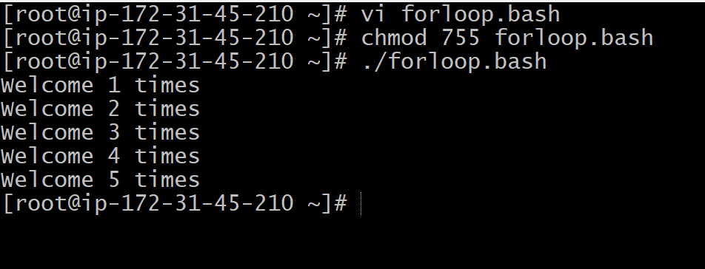
Changed number of times from 1 to 100
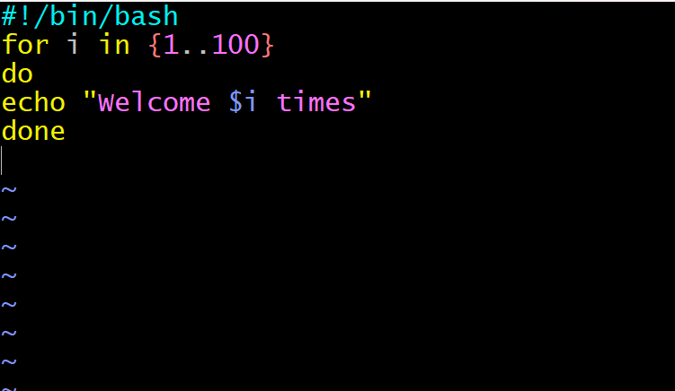
* I have changed number from 1 to 5 times, and created new to 1 to 100 and checked the output gave permissions using chmod 755 changed the script name to forloop.bash.

Output:

* output is successful u can see 100 times.
Do- while scripts
* created a new script with the name of “while.bash”
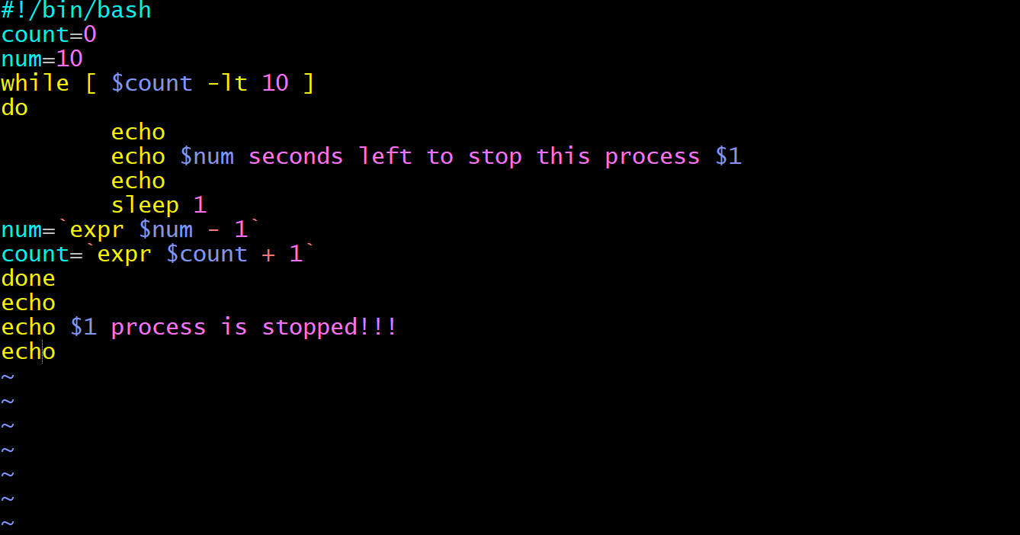
Output: Executed Do-while script
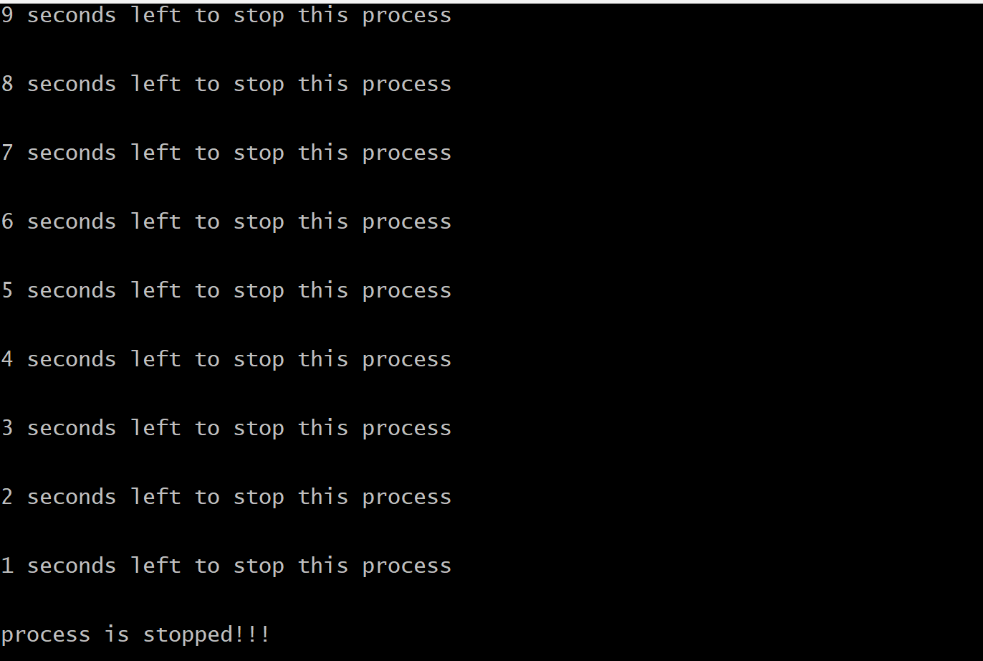
Exist status
* Created a new script “exit.bash”
* Given $ ?

Output:
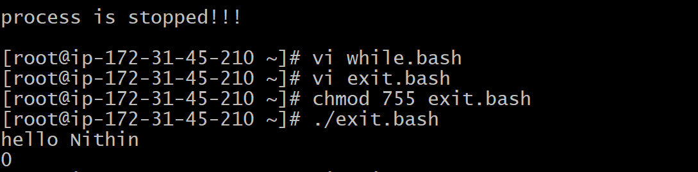
* U can see hello Nithin & “0”, means command successful.
Created a script using “File does not exist”
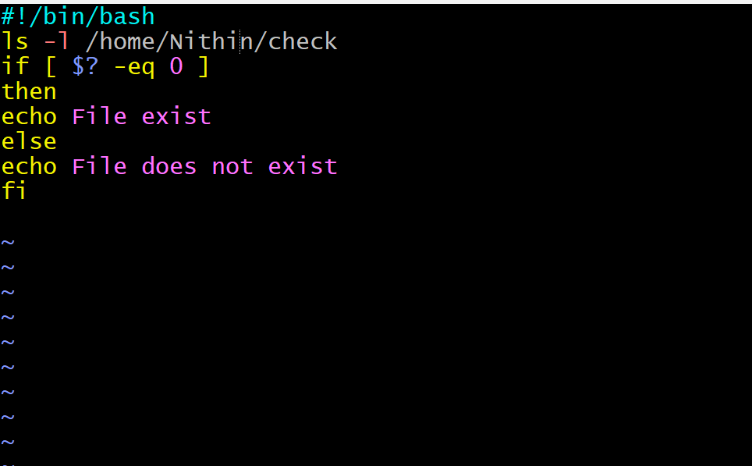
Output
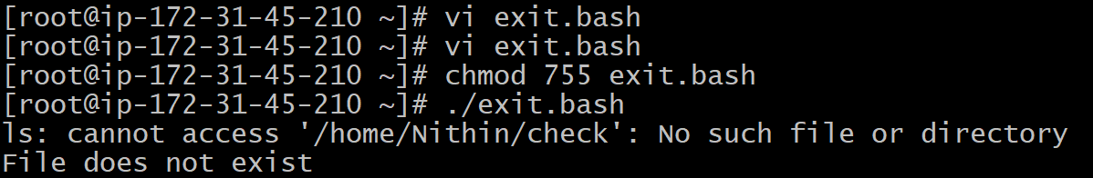
* We can see “file doesn’t exist” output is successfully.

